Name: Basith Raja
GSIT Oct’25 Morning Batch

OOPS Concept Assignment Questions& Answers

1.Encapsulation + Getter/Setter - Done

WAP in Java
Create a class named Employee with private instance variables empId, empName, and salary.
Provide public getters and setters for all variables.
Create a method displayDetails() to print employee details.
Create an object in the main method and assign values using setters then display them.

Code:

package oopsAssesment;

class Employee {

private int empID;
private String empName;
private float salary;
public int getEmpID() {
return empID;
}
public void setEmpID(int empID) {
this.empID = empID;
}
public String getEmpName() {
return empName;
}
public void setEmpName(String empName) {
this.empName = empName;
}
public float getSalary() {
return salary;
}
public void setSalary(float salary) {
this.salary = salary;
}

void displayDetails() {

System.out.println("Employee ID: "+ empID);
System.out.println("Employee Name: "+ empName);
System.out.println("Employee Salary: "+ salary);

}

}

public class EncapsulationGetterSetter1 {

public static void main(String[] args) {

Employee obj = new Employee();
obj.setEmpID(1234);
obj.setEmpName("Basith Raja");
obj.setSalary(90000);
obj.displayDetails();

}

}

Output:
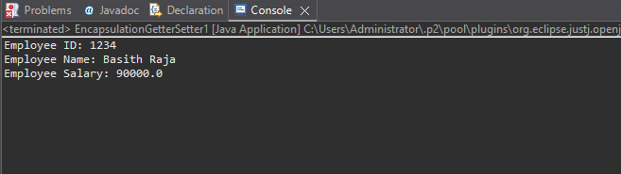

---------------------------------------------------------------

2. Inheritance + Method Overriding - Done

Create a base class Vehicle with a method fuelType() which prints "Runs on fuel".
Create a child class ElectricCar and override the fuelType() method to print "Runs on electricity".
Create objects of both classes and call their respective methods.

Code:

package oopsAssesment;

class Vehicle {

void fuelType() {

System.out.println("Runs on fuel");
}
}

class ElectricCar extends Vehicle {

@Override
void fuelType() {

System.out.println("Runs on electricity");
}

}

public class InheritanceMethodOverriding2 {

public static void main(String[] args) {

Vehicle obj = new Vehicle();
ElectricCar obj1 = new ElectricCar();
obj.fuelType();
obj1.fuelType();

}

}

Output:

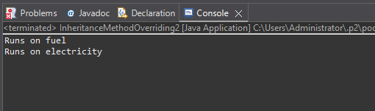

---------------------------------------------------------------

3. Constructor Overloading - Done

Create a class Product having instance variables productId, productName, and price.
Implement:

A default constructor that prints "Product Created".

A parameterized constructor that initializes the product details.
Write a method displayProduct() to print product details.
Create both types of objects in the main method.

Code:

package oopsAssesment;

class Product {

int productID;
String productName;
double productPrice;

Product() {

System.out.println("Product Created");
}

Product(int i, String n, double p) {
productID=i;
productName=n;
productPrice=p;

}

void displayProduct() {

System.out.println("Product ID: "+ productID);
System.out.println("Product Name: "+ productName);
System.out.println("Product Price: "+ productPrice);
}
}

public class ConstructorOverloading3 {

public static void main(String[] args) {

Product obj = new Product();
Product obj1 = new Product(1234,"Mobile",150000);
obj1.displayProduct();

}

}

Output:

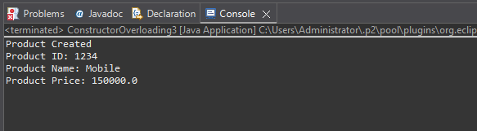
---------------------------------------------------------------

4. Method Overloading - Done

Create a class Calculator with overloaded methods add():

add(int a, int b)

add(double a, double b)
Call both methods inside the main method and print results.

Code:

package oopsAssesment;

class Calculator {

int add (int a,int b) {
int c = a+b;
return(c);
}
double add (double a,double b) {
double d = a+b;
return(d);
}

}
public class MethodOverloading4 {

public static void main(String[] args) {

Calculator obj = new Calculator();
System.out.println(obj.add(123,321));
System.out.println(obj.add(90000.0, 150000.0));

}

}

Output:

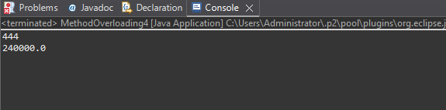

---------------------------------------------------------------
5. Abstraction using Abstract Class - Done

Create an abstract class Animal with an abstract method sound().
Create two subclasses Dog and Cat and provide implementation for sound() method.
Create objects and call sound() for each.

Code:

package oopsAssesment;

abstract class Animal{

abstract void sound();

}

class Dog extends Animal {

void sound() {
System.out.println("Dog sound: Bark");
}

}
class Cat extends Animal {

void sound() {
System.out.println("Cat sound: Meow");
}
}

public class AbstractionusingAbstractClass5 {

public static void main(String[] args) {

Dog obj = new Dog();
Cat obj1 = new Cat();
obj.sound();
obj1.sound();

}

}

Output:
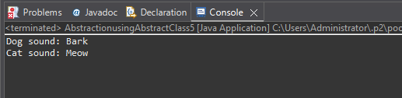

---------------------------------------------------------------

6. Interface Implementation - Done

Create an interface Payment with a method makePayment().
Create two classes UPI and CreditCard implementing this interface and define their own payment messages.
Call the method through interface reference.

Code:

package oopsAssesment;

interface Payment{

void makePayment();

}

class UPI implements Payment{

public void makePayment() {

System.out.println("Your Money has been successfully transferred through UPI");

}

}

class CreditCard implements Payment {

public void makePayment() {
System.out.println("Your Money has been sucessfully transferred through Credit Card");
}
}
public class InterfaceImplementation6 {

public static void main(String[] args) {
Payment ref = new UPI();
Payment ref1 = new CreditCard();
ref.makePayment();
ref1.makePayment();
}

}

Output:

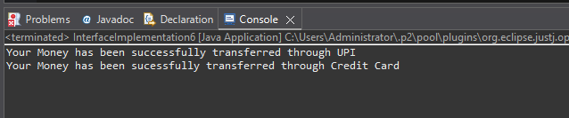

---------------------------------------------------------------

7. Use of super keyword - Done

Create a class Person with a constructor that prints "Person Created".
Create a subclass Student that calls the parent constructor using super() and prints "Student Created".
Create an object and observe the order of execution.

Code:

package oopsAssesment;

class Person {

Person(){
System.out.println("Person Created");
}
}

class Student extends Person {

Student(){
super();
System.out.println("Student Created");
}
}

public class Useofsuperkeyword7 {

public static void main(String[] args) {

Student obj = new Student();

}

}

Output:
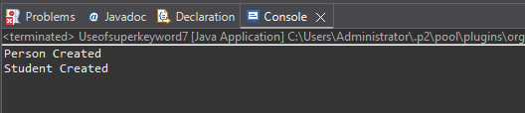

---------------------------------------------------------------

8. Polymorphism (Dynamic Binding) - Done

Create a parent class Shape with a method area().
Create subclasses Rectangle and Circle and override the area() method.
Create a reference of Shape and assign objects of both subclasses one by one, calling area() each time.

Code:

package oopsAssesment;

class Shape{

void area() {
System.out.println("Shape class");
}

}

class Rectangle extends Shape {

@Override
void area() {
System.out.println("Rectangle class");
}
}

class Circle extends Shape {

@Override
void area() {
System.out.println("Circle class");
}
}

public class PolymorphismDynamicBinding8 {

public static void main(String[] args) {
Shape ref;

ref = new Rectangle();
ref.area();
ref = new Circle();
ref.area();
}

}

Output:

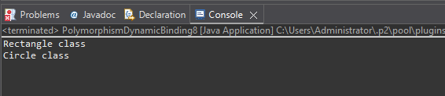

---------------------------------------------------------------

9. Final Keyword - Done

Create a class Bank with a final variable IFSC and final method showIFSC().
Try creating a subclass HDFCBank and attempt overriding the final method (should show compile-time restriction).
Create a main method to demonstrate usage.

Code:

package oopsAssesment;

class Bank {

final String a = "IFSC";
final void showIFSC() {
System.out.println(a);
}
}

class HDFCBANK extends Bank {

@Override
void showIFSC() {
System.out.println("Trying Override");
}
}
public class FinalKeyword9 {

public static void main(String[] args) {
Bank ref;

ref = new HDFCBANK();
ref.showIFSC();

}
}

Output:

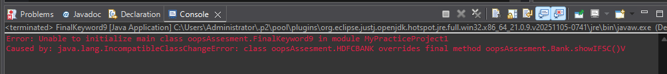

---------------------------------------------------------------

10. Static Keyword - Done

Create a class Student having static variable collegeName and instance variables name and rollNo.
Write a method to print both static and instance data.
Create multiple objects to show static value remains constant.

Code:

package oopsAssesment;

class Student1 {

static String collegeName = "Maxwell";
String name;
int rollNo;

Student1(String n, int r){

name = n;
rollNo = r;
}
void printMethod() {

System.out.println(name+" "+rollNo+" "+collegeName);
}
}
public class StaticKeyword10 {

public static void main(String[] args) {
Student1 obj=new Student1("Basith",777);
obj.printMethod();
Student1 obj1=new Student1("Raja",778);
obj1.printMethod();
Student1 obj2=new Student1("Ajith",779);
obj2.printMethod();

}

}

Output:

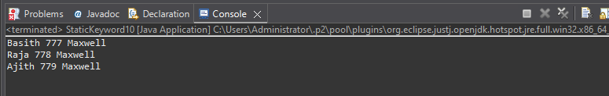

---------------------------------------------------------------

11. Class + Object + Method - Done

Create a class Library with an instance variable libraryName.
Create a default constructor to print "Welcome to the Library!".
Create a method showLocation() which prints "This library is located in Mumbai".
Create an object in main() and call both.

Code:

package oopsAssesment;

class Library{

String libraryName="Basith Library";

Library(){

System.out.println("Welcome to the Library!");
}
void showLocation(){
System.out.println(libraryName+" "+": This Library is located in Mumbai");
}
}
public class ClassObjectMethod11 {
public static void main(String[] args) {
Library obj = new Library();
obj.showLocation();
}

}

Output:

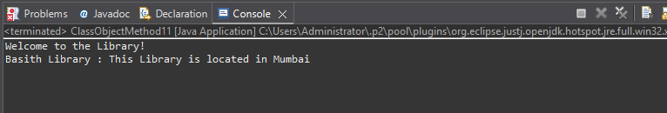
---------------------------------------------------------------

12. Encapsulation + Validation Logic - Done (But should discuss the code with saurabh)

Create a class Account with private variables accountHolderName and balance.
Provide setters and getters, where:

setBalance() should not accept negative values (print a warning).
Create an object and update values through setters only.

Code:

package oopsAssesment;

class Account {

private String accountHolderName;
private double balance;

public String getAccountHolderName() {
return accountHolderName;
}
public void setAccountHolderName(String accountHolderName) {
this.accountHolderName = accountHolderName;
}
public double getBalance() {
return balance;
}
public void setBalance(double balance){

if (balance<0) {
System.out.println("Warning: Negative values are not accepted !");
} else {
System.out.println("Available Balance: "+ balance);
}
this.balance = balance;
}

}

public class EncapsulationValidationLogic12 {

public static void main(String[] args) {
Account obj = new Account();
obj.setAccountHolderName("Basith Raja");
System.out.println("Acccount Holder Name: "+obj.getAccountHolderName());
obj.setBalance(-1000);

}

}

Output:

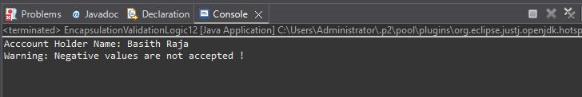

---------------------------------------------------------------

13. Inheritance (Multilevel) - Done

Create three classes:

Device â†’ method start()

Mobile extends Device â†’ method calling()

SmartPhone extends Mobile â†’ method internet()
Create object of SmartPhone and call all methods.

Code:

package oopsAssesment;

class Device {

void start() {
System.out.println("Start the Device");
}
}
class Mobile extends Device {
void calling() {
System.out.println("Calling to a friend through mobile");
}
}

class SmartPhone extends Mobile {
void internet() {
System.out.println("SmartPhones requires Internet to access webportal");
}
}

public class InheritanceMultilevel13 {

public static void main(String[] args) {
SmartPhone obj = new SmartPhone();
obj.start();
obj.calling();
obj.internet();

}

}

Output:

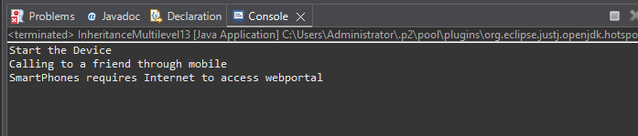

---------------------------------------------------------------

14. Hierarchical Inheritance - Done

Create a class Course with a method courseInfo().
Create subclasses Science, Commerce, and Arts each with their own method.
Create objects of each and call methods to show hierarchy.

Code:

package oopsAssesment;

class Course {

void courseInfo() {
System.out.println("Course Subjects are as follows:");
}
}

class Science extends Course {

void scienceSubjects () {
System.out.println("Science: Physics,Chemistry,Botany,Zoology");
System.out.println();
}
}

class Commerce extends Course {

void CommerceSubjects() {
System.out.println("Commerce: Statistics,Accounts,Payments,Bankings");
System.out.println();
}
}

class Arts extends Course {
void artsSubject() {
System.out.println("Arts: English,History,Literature,Computer Science");
System.out.println();
}
}

public class HierarchicalInheritance14 {

public static void main(String[] args) {
Science obj = new Science();
obj.courseInfo();
obj.scienceSubjects();
Commerce obj1 = new Commerce();
obj1.courseInfo();
obj1.CommerceSubjects();
Arts obj2 = new Arts();
obj2.courseInfo();
obj2.artsSubject();

}

}

Output:

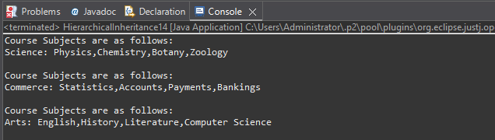

---------------------------------------------------------------

15. Method Overloading (Bank Scenario) - Done

Create a class LoanCalculator with two overloaded methods:

calculateLoan(int amount)

calculateLoan(int amount, double interestRate)
Print loan details accordingly. Call both methods from main.

Code:

package oopsAssesment;

class LoanCalculator{

int calculateLoan (int amount) {

return amount;
}

double calculateLoan (int amount, double interestRate) {
return amount + (amount*(interestRate/100));

}

}

public class MethodOverloadingBankScenario15 {

public static void main(String[] args) {
LoanCalculator obj = new LoanCalculator();
System.out.println("Loan Amount: "+obj.calculateLoan(100000));
System.out.println("Overall Payback Amount(Includes Interest): "+obj.calculateLoan(100000, 9.0));

}

}

Output:

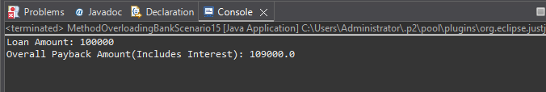

---------------------------------------------------------------

16. Method Overriding with super - Done

Create a base class Hospital with a method emergencyService().
Create a subclass CityHospital that overrides the method and calls parent method using super.emergencyService().
Demonstrate overriding in main.

Code:

package oopsAssesment;

class Hospital {

void emergencyService() {
System.out.println("Emergency Service will be provided for Critical patients");
}
}

class CityHospital extends Hospital {

@Override
void emergencyService() {

System.out.println("Emergency Services will not be provided for Non-Critical patients ");
super.emergencyService();
}

}
public class MethodOverridingwithsuper16 {

public static void main(String[] args) {

CityHospital obj = new CityHospital();
obj.emergencyService();

}

}

Output:

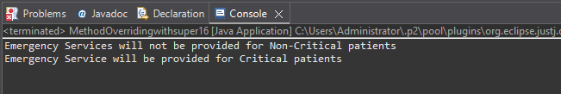

---------------------------------------------------------------

17. Abstract Class + Real Usage - Done

Create an abstract class Employee with:

abstract method: calculateSalary()

concrete method: employeeDetails()
Subclass FullTimeEmployee and PartTimeEmployee implementing salary calculation logic differently.

Code:

package oopsAssesment;

abstract class Employee1 {

void employeeDetails() {

System.out.println("Parttime Employee Name: Ajith");
System.out.println("Fulltime Employee Name: Basith Raja");
System.out.println();

}
abstract double calculateSalary(int a, double b);

}

class ParttimeEmployee extends Employee1 {

double calculateSalary(int totalworkinghoursperday, double salaryPerHour) {
return(totalworkinghoursperday*salaryPerHour);

}

}

class FulltimeEmployee extends Employee1 {

double calculateSalary(int totalworkingdayspermonth, double salaryPerDay) {
return(totalworkingdayspermonth*salaryPerDay);

}

}

public class AbstractClassRealUsage17 {

public static void main(String[] args) {

Employee1 ref = new ParttimeEmployee();
Employee1 ref1 = new FulltimeEmployee();

ref.employeeDetails();
System.out.println("Ajith Salary is: "+ ref.calculateSalary(4,200)+" "+ "Per Day");
System.out.println("Basith Raja Salary is: "+ ref1.calculateSalary(30,1600)+" "+"Per Month");

}

}

Output:

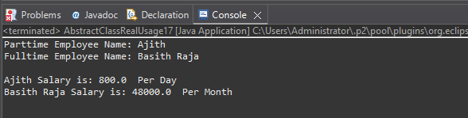

---------------------------------------------------------------

18. Interface with Multiple Implementations - Done

Create an interface Transport with method booking().
Implement it in Bus and Flight classes.
Call using interface reference.

Code:

package oopsAssesment;

interface Transport {

void booking();

}

class Bus implements Transport {

public void booking() {
System.out.println("Bus ticket booking is easy and cheaper");

}

}

class Flight implements Transport{

public void booking() {

System.out.println("Flight ticket booking is hard and costlier");

}
}

public class InterfacewithMultipleImplementations18 {

public static void main(String[] args) {

Transport ref;
ref = new Bus();
ref.booking();

ref = new Flight();
ref.booking();

}

}

Output:

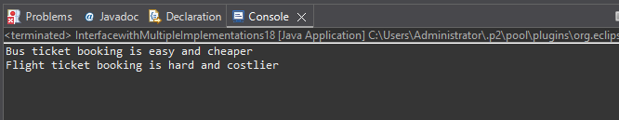

---------------------------------------------------------------

19. Polymorphism (Runtime + Upcasting) - Done

Create a class Camera with a method capture().
Create a subclass DSLCamera that overrides the method.
Use parent reference to call child object method (dynamic polymorphism).

Code:

package oopsAssesment;

class Camera {

void capture() {
System.out.println("Camera capture images");
}
}

class DSLCamera extends Camera{

@Override
void capture() {
System.out.println("DSLCamera capture images in better quality");
}

}
public class PolymorphismRuntimeandUpcasting19 {

public static void main(String[] args) {

Camera ref = new DSLCamera();
ref.capture();

}

}

Output:

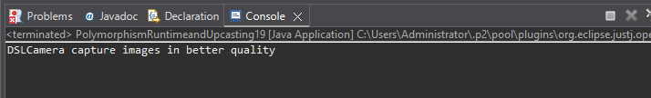

---------------------------------------------------------------

20. Aggregation (Has-A Relationship)

Create a class Engine with a method engineInfo().
Create a class Car that has-a Engine object and uses it to show engine details.
Show aggregation in main method.

---------------------------------------------------------------

21. Static Concepts - Done

Create a class University with:

static variable country = "India"

instance variable universityName
Print values using different objects to show static effect.

Code:

package oopsAssesment;

class University {

static String country = "India";
String universityName;

University(String U) {

universityName=U;
}

void toPrint() {
System.out.println(universityName+", "+"Location: "+ country);
}

}
public class StaticConcepts21 {

public static void main(String[] args) {

University obj = new University("Anna University");
obj.toPrint();
University obj1 = new University("SRM University");
obj1.toPrint();
University obj2 = new University("IIT University");
obj2.toPrint();
University obj3 = new University("kamaraj University");
obj3.toPrint();
University obj4 = new University("Islamic University");
obj4.toPrint();
}

}

Output:

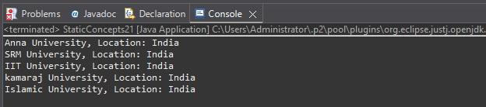

---------------------------------------------------------------

22. Final Keyword + Constant - Done

Create a class GovernmentRules with a final variable MAX_WORKING_HOURS = 8
Try modifying it inside main and observe compile-time restriction.

Code:

package oopsAssesment;

class GovernmentRules {

final int MAX_WORKING_HOURS = 8;

GovernmentRules(int m){
MAX_WORKING_HOURS=m;
}

void method() {

System.out.println(MAX_WORKING_HOURS);
}

}

public class FinalKeywordConstant22 {

public static void main(String[] args) {
GovernmentRules obj = new GovernmentRules(100);
obj.method();

}

}

Output:

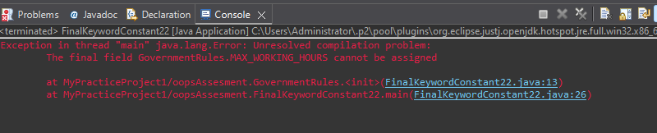

---------------------------------------------------------------

23. Constructor Chaining - Done

Create a class Mall with:

Default constructor printing "Welcome to the Mall"

Parameterized constructor calling default constructor using this()
Demonstrate constructor chaining in main.

Code:

package oopsAssesment;

class Mall {

Mall() {
System.out.println("Welcome to the Mall");
}

Mall(String a ){

this();
System.out.println("Constructors Chained");
}

}

public class ConstructorChaining23 {

public static void main(String[] args) {
Mall obj = new Mall("Basith");

}

}

Output:

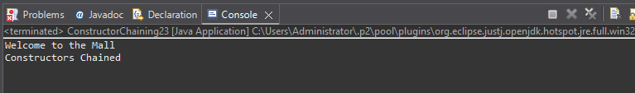

---------------------------------------------------------------

24 > WAP in Java - Done
Create a Class named Shape with length as instance variable , create three methods as square , rectangle , circle
and find out their respective areas
Create a object in main method and call these different methods with the instance of object

Code:

package oopsAssesment;

class Shape1{

int square(int s) {
return s*s;
}

int rectangle (int length, int breath) {
return length*breath;
}

double circle(double pi, int r) {
return pi*(r*r);
}
}

public class WAPinJava24 {

public static void main(String[] args) {

Shape1 obj = new Shape1();
System.out.println("Area of Square: "+obj.square(4)+" "+ "sq.units");
System.out.println("Area of Rectangle: "+obj.rectangle(20,10)+" "+ "sq.units");
System.out.println("Area of Circle: "+obj.circle(3.14, 10)+" "+ "sq.units");

}

}

Output:

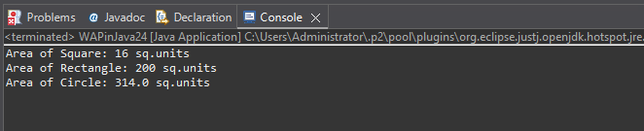

---------------------------------------------------------------

25> WAP in Java - Done
Create a class named school ,create name as their instance variables
Create a default constructor of this class which will have a print statement to display the name of school
Create a method inside the class which will display a message as "This School is based out of Kolkata"
Create a object under main method and call the constructor and the method

Code:

package oopsAssesment;

class School {

String name = "Maxwell";

School(){
System.out.println("School Name is: "+ name);
}

void method() {
System.out.println("This School is based out of Kolkata");
}
}

public class WAPinJava25 {

public static void main(String[] args) {

School obj = new School();
obj.method();

}

}

Output:

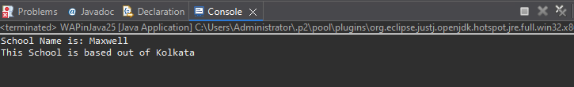

---------------------------------------------------------------

26> WAP in Java to create a class named school - Done
create name, address,strength as their instance variables
Create two constructor one with two variables and one with all the three variables
Create a method that will display all the three parameters
create two object of this class and call the respective methods

Code:

package oopsAssesment;

class School1 {

String name;
String address;
String strength;

School1(String name,String address){
this.name=name;
this.address=address;
}

School1(String name,String address, String strength){
this(name, address);
this.strength=strength;
}

void display() {
System.out.println(name+" "+address+" "+strength);
}
}

public class WAPinJava26 {

public static void main(String[] args) {

School1 obj = new School1("Maxwell","No.20/AP Road-Bangalore");
School1 obj1 = new School1("Maxwell","No.20/AP Road-Bangalore","Teaching Quality & Affordable fee structure");
obj.display();
obj1.display();
}

}

Output:



